**Challenge 2**

The preferred language here is Python, but if you are comfortable in another language that is also ok. Please provide clear instructions on how to run your code or any dependencies if needed. Please validate your code before you send it to us. Standalone scripts preferred over Jupyter Notebooks

Please create a command line tool which can be used to remove users from databases.

Requirements:

* A path to a file containing a newline separated list of PostgreSQL connection strings will be passed as an argument
* The username will be passed as an argument
* The user may on may not exist in every database
* The user may or may not own database objects
* Ideally, the user would be dropped, but setting the nologin attribute is acceptable
* The program should output a text file. Each line should feature the database name, whether or not the user was found, and the action taken if found

Solution

Created a solution for a generalized command line tool for the db activity.

Please find the tools used for the requirements.

Language Used: Python 3.8 version

Installed Packages : psycopg2

Default Packages : datetime,logging, os, sys,traceback

Modules Created: sqlqueries, lib

The base script is dbshipt.py

Modules/Classes Created under lib directory:

1. PgCon.py
2. PgOp.py
3. Usercheck.py

Modules/Classes created for SQL Queries

1. Useractivity.py

*Script Help Syntax:*

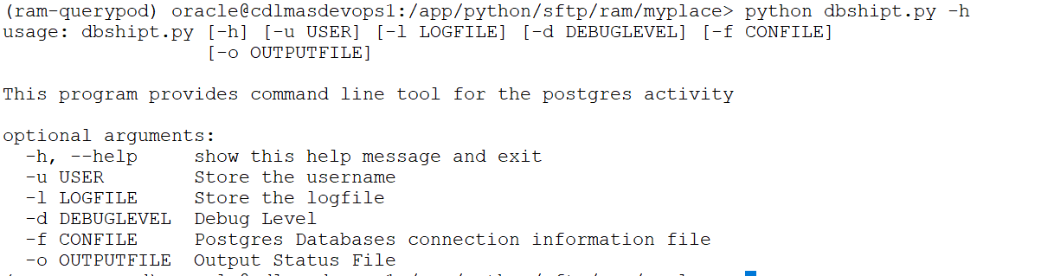

*Execution:*

python dbshipt.py -u test -f connections.txt -d DEBUG

The Script generates two logfiles by default. One logging for the script process and the one output file for the script output.